Networking Exercise 003-DNS

- DNS:Converts Websites names into IP adresses because of this your device knows where to go and can commuicate with the website. The reason why its conveted into plain text for example google.com is because humans can't remember numbers very well but computers can because computers can only read numbers and communicate with webistes using ip adresses. DNS basically translates website names properly into their IP adress if website names weren't converted properly this is will lead too a internet connection problem.DNS bascially tells your computer a webists adress in a way it understand IP adress it like finding an address without it your computer will not find the address.DNS server is usally in your routwe
- nslookup: a command prompt lets us know IP adress of a webiste

Objective:
Check whether my laptop can translate a website name into an IP address.
Tools Used:
- Command Prompt (cmd)
- nslookup: checks whether DNS can successfully find the IP address of a website.
Command Used:nslookup
What I observed:
- Google was successfully found.
- One or more IP addresses were displayed.
- I could see which server was being used.
What I learned:
- DNS converts website names into IP addresses.
- Computers use IP addresses to locate websites.
- If DNS fails, websites may not load even if Wi-Fi is connected. nslookup can help investigate DNS problems.
- DNS asked my router to to help find googles address
- google has many servers many locations and data centres this most likey the IP address of servers nearest too my location gthis because many people use google they can't afford a seerver not working so they need mutiple servers to reduce the risk
Skills demonstrated:
- Networking fundamentals
- Command Prompt usage
- Basic troubleshooting
- DNS investigation

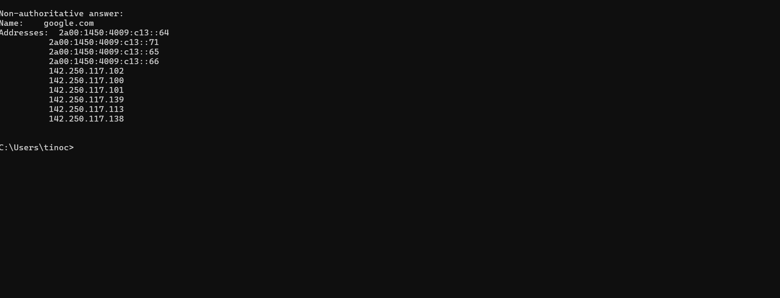

C:\Users\tinoc>nslookup google.com
*** Default servers are not available
Server: UnKnown
Address: 127.0.0.1

*** UnKnown can't find google.com: No response from server

C:\Users\tinoc>DNS

Result; if internet is not connected too a route you computer cannot relibaly ask dns too find the IP address of google.com

